THE CHURCH IN NEW YORK CITY
CHILDREN’S MEETING LESSON

DATE: March 24, 2019
SUBJECT: THE LORD’S PRAYER—A Model: (8) Not Being Brought into Temptation, but Being Delivered from Evil (Disobedience and Rebellion) (5 of 5)
SCRIPTURES: Matthew 6:13a; Luke 11:4b; Numbers 12, 16; Jonah 1-4; Genesis 11:31; 12:1-5; 21:1-5; 22:1-18; Acts 7:2-3; Hebrews 11:8
AIM: For the children to recognize that Satan tempts us to disobey and rebel, and to help them learn to obey and be respectful of authority.
SUGGESTED MEMORY VERSES TO CHOOSE FROM: Acts 5:29b (It is necessary to obey God rather than men.); 1 Samuel 15:22b (Behold, to obey is better than sacrifice, And to heed, than the fat of rams); Hebrews 13:17a (Obey the ones leading you and submit to them...); Genesis 27:8 (Now therefore, my son, obey my voice, according to that which I command you.); Ephesians 6:1 (Children, obey your parents in the Lord, for this is right.); Colossians 3:20 (Children, obey your parents in all things, for this is well pleasing in the Lord.)
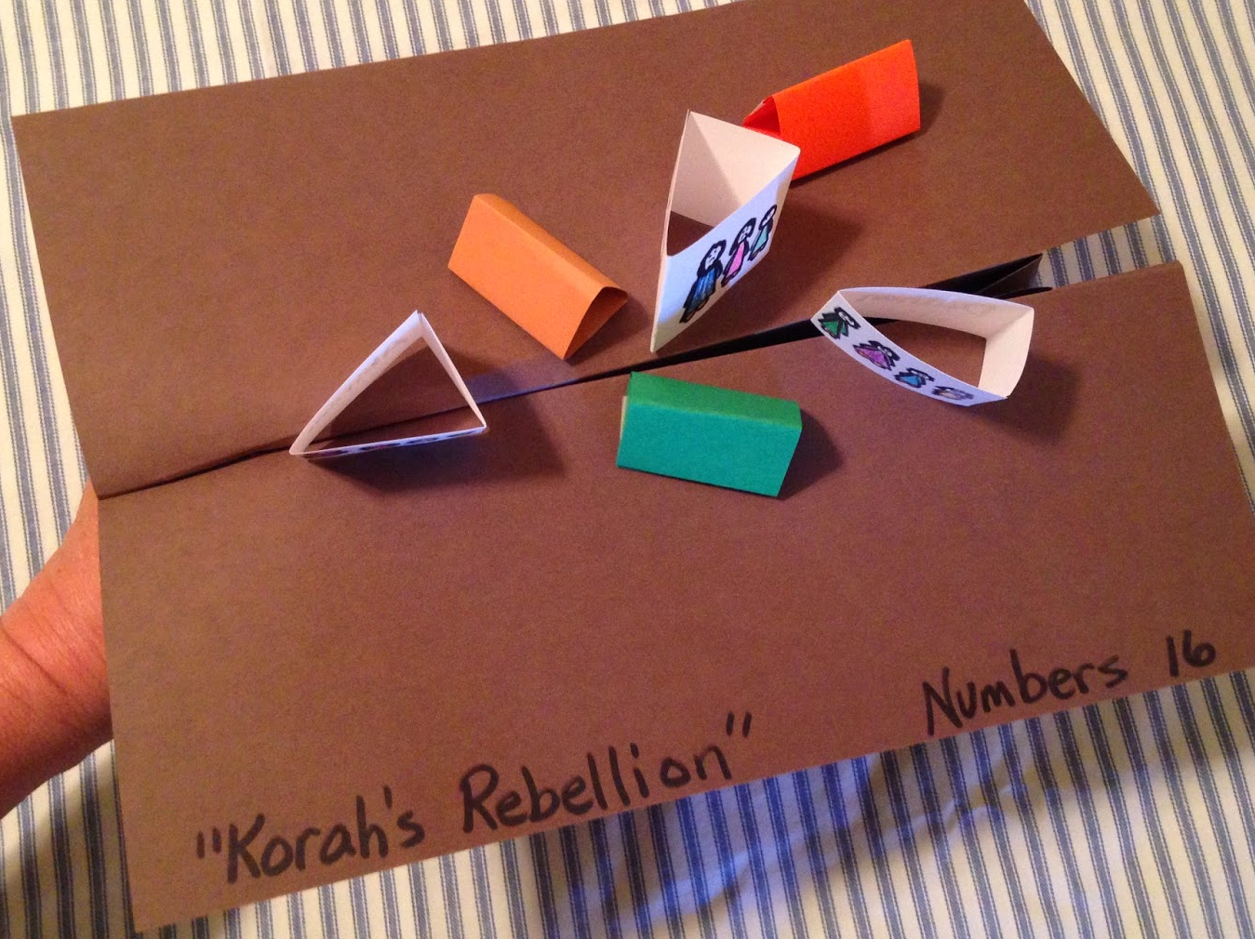
SUGGESTED SONGS: 10 (Inside Me); 153 (Obey His Call); 173 (To the Foe My Word is Always “No”); 174 (When Ugly Satan Knocks At My Heart’s Door); 1614 (C-O-O-P-E-R-A-T-I-O-N); 6732 (Trust and Obey); 9204 Bible Story Songs David Song #4 (Honor, Honor, Honor, Honor); 9311 BSS Daniel Song #11 (Let the Name of God Be Blessed); 2829 (Honor and Respect for Authority)
CRAFT IDEA: Use construction paper to create a ground that can “open up” and “consume” the “tents” of Korah and his collaborators, as in the image to the right. Full instructions can be found at the bottom of the website:
http://childrensbiblelessons.blogspot.com/2014/05/lesson-rebelling-against-god.html
BACKGROUND: In the model of prayer the Lord gave us, Matthew 6:13a says, “And do not bring us into temptation, but deliver us from the evil one.” We have been talking about some of the main ways Satan tries to tempt us, i.e., to be proud, greedy, covet what others have, and to be jealous. This week, we will see another major way in which Satan tempts us—to disobey and rebel.

APPROACH: Ask the children whom they consider authority over them. Make a written list of their responses, such as parents, grandparents, teachers, police officers, serving ones, etc. Ask the children if sometimes they do not want to listen to their parents, teachers, etc. That feeling is rebellion.

CONTENT: Satan’s Temptations (continued)
IV. To rebel and disobey. To rebel is to resist or oppose authority or government. To disobey is to refuse to obey. Originally, the universe God created for His purpose was in perfect order with God as its Ruler. But Satan rebelled against God, disrupting the order of the universe. This is why we may see chaos and destruction around us or hear about it in the news. God wants to reestablish the proper order in the universe but Satan wants the whole world to follow him in his disobedience and rebellion. Today, he still wants us to follow him, and tempts us very much to be rebellious and disobedient.

If we have not yet done so in our class, we may want to give some background on the first rebellion in the universe, the rebellion of Satan. We see in Isaiah 14:12-15, that one angel Lucifer (meaning light-bearer, and translated as “Daystar” in the Recovery Version) rebelled against the authority of God and tried to make himself equal to God, and he was judged and cast out by God, and became God’s enemy: “12 How you have fallen from heaven, O Daystar, son of the dawn! How you have been hewn down to earth, You who made nations fall prostrate! 13 But you, you said in your heart: I will ascend to heaven; Above the stars of God I will exalt my throne. And I will sit upon the mount of assembly In the uttermost parts of the north. 14 I will ascend above the heights of the clouds; I will make myself like the Most High. 15 But you will be brought down to Sheol, To the uttermost parts of the pit.” Satan is the root of all disobedience and rebellion!

Here are some examples in the Bible of disobedience and obedience and what happened as a result:

Note to serving ones: It is not meant that all the details of the Scripture portions be given to the children. The portions are included to emphasize the matter of rebellion in contrast to obedience, and can be told in a brief way. Please fellowship in your group over which example or examples to choose as age-appropriate, especially for younger children. Consider both their capacity to understand and their attention span.

Adam and Eve (Genesis 1:26-27; 3:1-10). God created Adam in a very special way, different from the animals. God commanded Adam that he could freely eat of every tree in the garden where God put him, except for one tree. But Adam and his wife, Eve, disobeyed God and ate fruit from the tree that God had said not to eat. Satan had come in as a serpent and tricked them. Though God forgave Adam and Eve, God had to discipline them. They were cast out of the garden where God supplied everything for them, they had to work hard in order to survive, they were cut off from the tree of life, and eventually suffered from physical death.

Miriam and Aaron (Numbers 12). God had chosen Moses as His deputy authority to lead the children of Israel out of Egypt and through the wilderness during their journey to the promised land. Moses took a Cushite woman as his wife, a matter which displeased his older sister Miriam and brother Aaron. Miriam and Aaron spoke out against Moses, even challenging his authority, saying “Has Jehovah indeed spoken only through Moses? Has He not also spoken through us?” God heard Miriam and Aaron, and rebuked them, saying “My servant Moses… is faithful in all My house...Why then were you not afraid to speak against My servant, against Moses?” (Numbers 12:7-8). God considered this a rebellion against the one He chose to lead His people. God judged this rebellion by causing Miriam to become leprous (suffer from a terrible skin disease) and be shut up outside the camp for a week.

Korah (Numbers 16). Korah was a Levite and a relative of Moses. Korah, together with three other men, Dathan, Abirom and On, gathered 250 prominent men of the Israelites to challenge Moses’ and Aaron’s authority. They did this while pretending to try to help them, saying “You [Moses and Aaron] take too much upon yourselves, for all the assembly are holy, every one of them, and Jehovah is among them.” (Numbers 16:3a) In actuality, their true feelings of jealousy and rebellion were revealed when they spoke to Moses and Aaron “Why then do you exalt yourselves above the congregation of Jehovah?” (Numbers 16:3b) Moses replied to Korah and his followers that they all, including Aaron, would take their censers (instruments of burning incense) and present them to God at the entrance to the tabernacle, to see whom God would accept. After they did this, God judged Korah’s rebellion by causing the ground to open up and swallow up the tents of Korah, Dathan and Abirom, and fire from God consumed the 250 followers. From this account, we can see how seriously God considers rebellion.
Jonah (Jonah 1-4). Nineveh was a city whose people worshipped idols instead of the real God; its people were wicked and had been especially cruel to God’s people. One day, the Lord spoke to His prophet, Jonah, to warn the Ninevites to repent. Rather than obeying, Jonah rose up to flee in the opposite direction—to the city of Tarshish. On the way there, Jehovah hurled a great wind toward the sea and there was a great tempest. At Jonah’s direction (knowing that it was his fault there was a great storm), the sailors took him and threw him into the sea. Jehovah had prepared a great fish to swallow Jonah up and he was in the stomach of the fish for three days and three nights. While Jonah was there he cried out and repented to Jehovah. Jehovah then commanded the fish to release Jonah, so it vomited him out onto the dry land. Then Jehovah told Jonah a second time to go to Nineveh to proclaim His word. This time Jonah obeyed. All the people of Nineveh, including the king, repented in a very sincere way. When God saw how the Ninevites repented, He decided not to destroy them.

V. A Positive Example of Obedience.

Abraham (Genesis 11:31; 12:1-5; 21:1-5; 22:1-18; Acts 7:2-3). One day, Jehovah told Abram to leave everything behind, to leave his country and family and go to a land that He would show him. Although Abram was seventy-five years old, he obeyed God. Abram, his wife, and his nephew left their country and their family and obeyed God to go to a land they had never seen before. God had promised Abram that he would have many descendants, and twenty-five years later, Isaac was born. One day, God asked Abraham to take Isaac to the land of Moriah and offer him there as a burnt offering. Abraham obeyed God and took Isaac and came to the place that God had told him. Just as Abraham was about to slaughter his son, the Angel of Jehovah called to him from the heavens and stopped him. Abraham lifted up his eyes and saw that behind him there was a ram caught in the thicket by its horns. Abraham took the ram and offered it up for a burnt offering in place of his son. The Angel of Jehovah called Abraham a second time from heavens and said, “…Because you have done this thing and have not withheld your son…I will surely bless you…And in your seed all the nations of the earth shall be blessed, because you have obeyed My voice”.

SUGGESTED APPLICATIONS TO CHOOSE FROM: Please pray and fellowship over which applications to cover. Please do not try to cover all the applications. It is sufficient to cover just one or two applications which are appropriate for the age group of the children you are serving.

- Wherever God rules, there is order and beauty and protection. Where Satan rules, there is chaos and danger. What if a class had no teacher? What if a family had no parents or adult taking care of the children? The situation would be chaotic. God has put people in charge of us to keep things in good order, and we need to obey them. Obedience to our parents, teachers and other authorities is a great protection. When we disobey and rebel, we may lose their protection and may find ourselves in difficult and perhaps dangerous situations. In order, there is beauty. How lovely it is when children in a family are obedient and submissive to their parents! Everyone, including the Lord, is pleased and happy. On the contrary, how ugly, chaotic and sad it is when children talk back to their parents or teachers and disobey them. Only Satan is happy in such a situation. When we submit ourselves to God’s order, we will be blessed. We feel good inside, and outwardly, things are also peaceful.

- Disobedience and rebellion often result in negative consequences. In the Bible stories above, Miriam spoke against God’s chosen authority and became leprous; Korah rebelled and met a terrible end, and brought judgment on the people of Israel; Jonah disobeyed and went through a lot of trouble, but eventually he obeyed. On the other hand, Abraham followed God even though it was difficult, and received God’s blessing.

Adapted from the Church in New York City children’s meeting lessons 8/22/82; 2/28/87; 9/23/90; 8/30/98; 9/1/02; 8/29/04; 9/11/05; 11/13/05;12/4/05; 4/9/06; 7/09/06; 3/30/08; 3/23/14

