THE CHURCH IN NEW YORK CITY
CHILDREN’S MEETING LESSON

LESSON #13
DATE: December 8, 2019
SUBJECT: THE TRAVELS OF THE CHOSEN CHILDREN OF ISRAEL: The Ten Commandments (2 of 2)
SCRIPTURE: Exodus 20:1-2, 12-17
AIM: To see that the laws God made show us what kind of person He is and what kind of people He wants us to be—like Him. God’s commandments also show us how we can please Him by obeying His commandments.
SUGGESTED MEMORY VERSES: Mark 12:31m (...You shall love your neighbor as yourself…); Isaiah 40:8 (The grass withers and the flower fades, / But the word of our God will stand forever.); Psalms 119:72 (The law of Your mouth is better to me / Than thousands of pieces of gold and silver.)
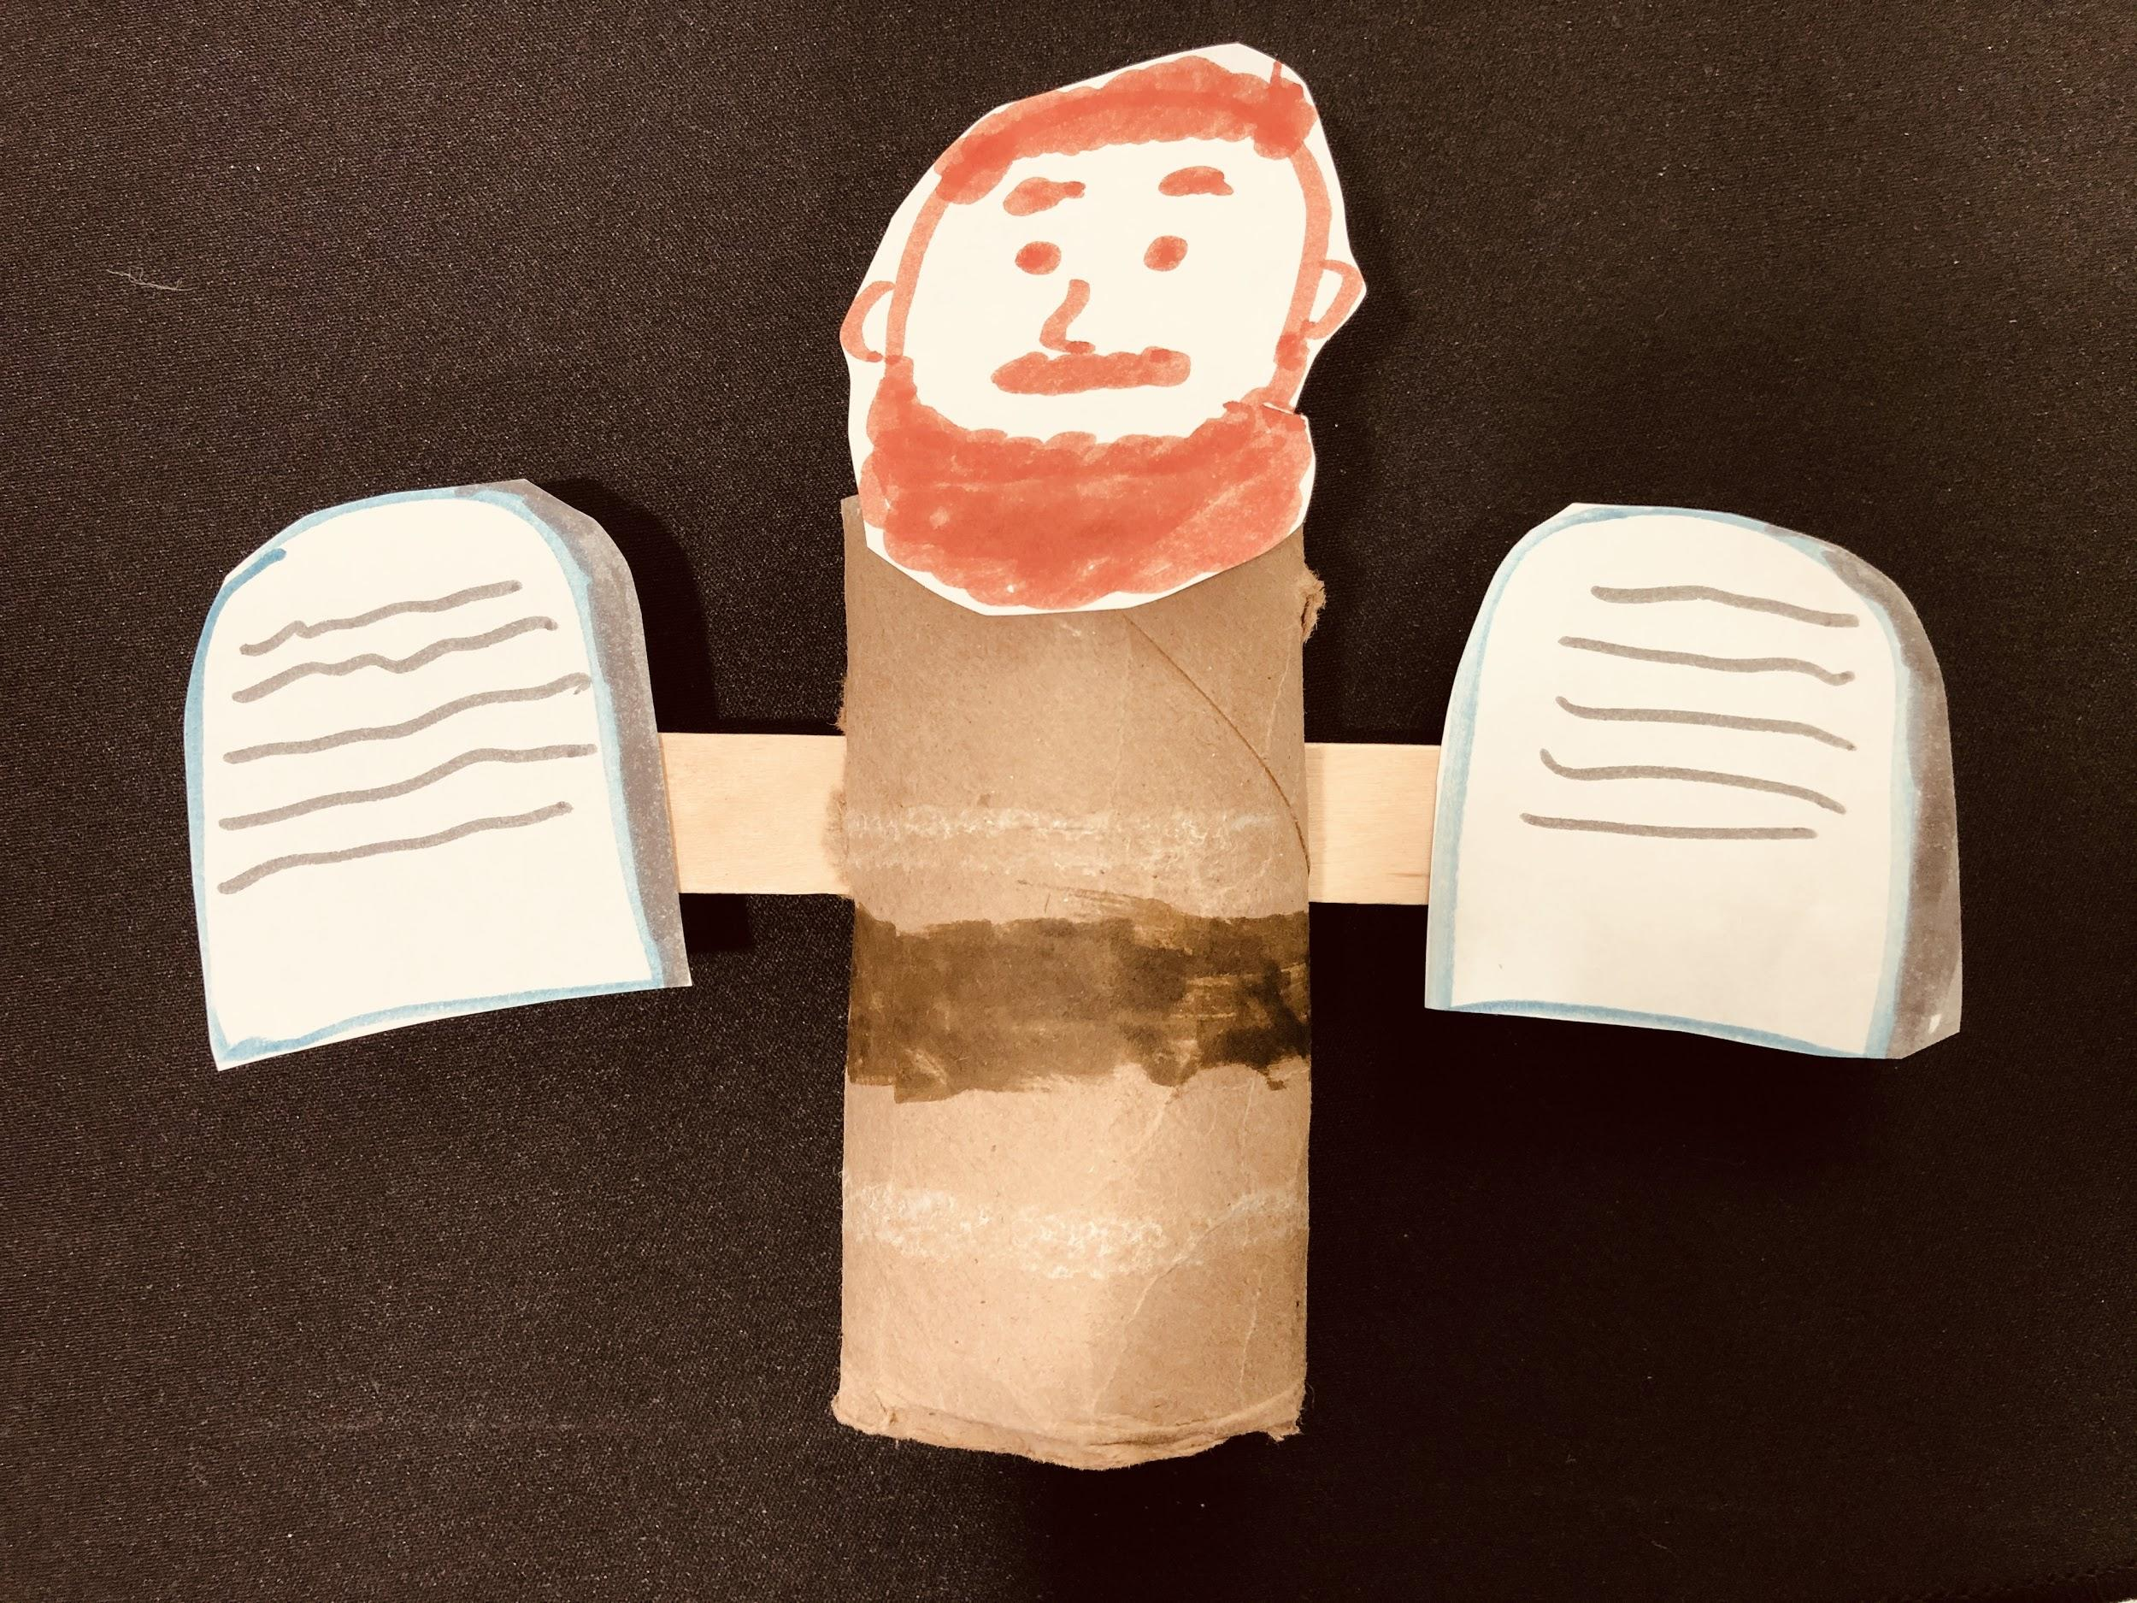
SUGGESTED SONGS: 51 (God); 9010 BSS God’s Design Creation Vol.1 #10 (You Are Mindful of Man); 6711 BSS Matthew Vol.2 #20 (The Great Command); 9530 BSS Vessels Unto Honor #10 (Speak Truth); 5508 (Lying Lips Are An Abomination); 9498 BSS Wonderfully Creation Vol.2 #20 (I Am Awesomely Made); 9522 BSS Vessels Unto Honor #2 (Everything We Do and Say); 146 (I Want the Lord to Have the First Place); 2834 (Work Hard and Do Not Steal); 3115 (How Do You Obey God’s Word?)
CRAFT IDEAS: (1) Cut out and decorate a construction paper heart as appropriate for your children’s ages and interests. Paste or write the verse Mark 12:31m. (2) Using a paper roll, thread through a popsicle stick for arms. Paste on cutouts of face for Moses and tablets for the Ten Commandments.

BACKGROUND: The previous lesson covered the first four Commandments which deal with man’s relationship with God. This lesson covers the last six Commandments which deal with man’s relationship with other men.

CONTENT: The Ten Commandments (continued)
5. Honor your father and your mother (Exodus 20:12a). God alone is to be worshipped by man, but our parents are to be honored. To honor our parents is to hold them in high regard and to give them much respect. God is our source, and we are here on earth because of God. God used our parents to give us life on the earth. When we honor our parents, we trace our origin back to our source, God Himself. God selected our parents just for us. If we dishonor those whom God selected to bring us into this world, we also dishonor God.

By honoring our parents, we honor God and receive His promised blessing. The Apostle Paul pointed out that this commandment is the first commandment with a promise. According to Exodus 20:12, if we honor our parents, our days will be long upon the earth. The blessing of long life helps us realize that God is our source, for only He, the source of life, can grant us a long life.

6. You shall not kill (Exodus 20:13). To kill (murder) is the intentional taking of a human being’s life (not an animal’s) out of malice. If appropriate for the age and situation of the children, we can also mention that the taking of human life also includes suicide. To kill is against God’s law because it is against His loving nature. To kill is to destroy human life. God alone is the source and giver of life. Therefore, He alone has the right to take it away. In the New Testament the Lord Jesus said, “You have heard that it was said to the ancients, you shall not murder…But I say to you that every one who is angry with his brother shall be liable to the judgment” (Matt. 5:21-22). Because murder comes from anger and hatred, we must not let anger and hatred fill our hearts.

7. You shall not commit adultery (Exodus 20:14). God’s original intention is for one man and one woman to be joined as one, as husband and wife. When men or women break God’s arrangement in marriage or annul their promise to be faithful to one another by leaving their spouse and marrying or living with someone else, they commit adultery.

8. You shall not steal (Exodus 20:15). To steal is to take another’s property, ideas, or things without permission in a dishonest or unlawful way, especially in a sneaky way. God supplies all our needs. People steal mainly because they are lazy and greedy, and do not trust in God to provide for them. Taking or touching other people’s property without permission also shows them disrespect. We should show proper respect for all the people God created. Cheating off of other students’ answers for a test or homework, or copying from books or Internet sites and pretending it’s our own work, is also a kind of stealing.

9. You shall not testify with false testimony against your neighbor (Exodus. 20:16). To bear false witness is to speak anything that is false in nature. God is a God of truth and His word is true. Because He is true He requires that we, His people, also be truthful and honest in our speech. To tell a lie about someone is to bear “false testimony” against him. That goes against God’s basic law of loving our neighbor as ourselves (Luke 10:27). In previous lessons, we gave examples of different kinds of lies, such as outright lies, careless lies, half-truths, silence, exaggeration, flattery, and cheating.

10. You shall not covet (Exodus 20:17a). To covet means to desire strongly; crave; long for (especially something that another person has). It is not limited to desiring material things from others, but may also include qualities such as beauty, intelligence, and strength.

The other nine commandments mainly deal with wrong and sinful actions; this commandment deals directly with our heart and thoughts. Covetousness in the heart eventually leads to sinful actions. To covet is to be dissatisfied, unhappy with what God has given us. Coveting offends God and makes us sad and miserable. The main cause of covetousness is not need, but being dissatisfied with what we have. Happiness does not come from possessing more; it comes from being satisfied and content with what we already have. We should be thankful for what God has provided for us.

SUGGESTED APPLICATION: All of the above commandments can be summarized in one verse, “… You shall love your neighbor as yourself …” (Mark 12:31). God is love. He wants us to be like Him. Therefore by loving our neighbor as ourselves we express God and show our love to Him.

Note to Serving Ones: For additional Lesson Resources for applications and Scripture references, please read the Ten Commandment series of lessons.

Adapted from Bringing Children from Adam to Christ in God’s Economy–Vol. 4, The Travels of the Chosen Children of Israel, Lesson 5, and from the Church in New York City’s Children’s meeting lessons: 8/28/88; 9/4/88; 9/11/88; 11/26/95; 12/7/03; 12/13/09; 12/07/14

