THE CHURCH IN NEW YORK CITY

**CHILDREN’S MEETING LESSON**

**LESSON #24**

**DATE:** March 1, 2020

**SUBJECT: THE TRAVELS OF THE CHOSEN PEOPLE OF ISRAEL: Conquering Jericho**

**SCRIPTURE:** Joshua 5:13-15; 6:1-27; Hebrews 11:30

**AIM:** To show the children that we can have a victory in every situation because our Lord is with us and because we believe and obey Him.

**MEMORY VERSES:** Hebrews 11:30a (By faith the walls of Jericho fell...); Romans 8:37 (But in all these things we more than conquer through Him who loved us.); 1 Corinthians 15:57 (But thanks be to God who gives us the victory through our Lord Jesus Christ.); Joshua 1:9b (...Be strong and take courage; do not be afraid or dismayed. For Jehovah your God is with you wherever you go.)

**SUGGESTED SONGS**:6103 Joshua (Rahab); 200 (Round the Walls of Jericho); 63 (By His Word); 3705 Joshua (Jericho); 46 (I’m in the Lord’s Army); 30 (Only Believe); 20 (All Things Are Possible); 25 (I Believe God); 2500 (Faith Is Just Believing)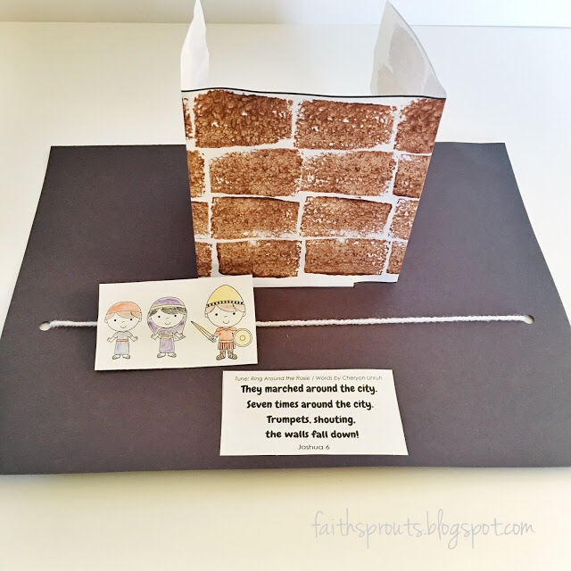

**CRAFT IDEAS:** 1) Using cardstock, make a paper trumpet, inspired by the rams’ horn trumpets of the priests. Decorate with paper cutouts, coloring, stickers, etc. 2) Using paper decorated to look like a wall, make a 3D wall around Jericho and add paper cutouts of the children of Israel marching around it (see example).

**BACKGROUND:** In the prior lesson, we learned that when Joshua and the children of Israel were about to enter into the good land, Joshua sent two spies into Jericho. A sinful woman Rahab hid them and made them promise that when Jehovah had given them the land, they would spare her and her household. Finally Joshua and the children of Israel crossed the river Jordan into the good land after wandering in the wilderness for 40 years. This was a new beginning for them. Let’s see what happened to them next.

**CONTENT:** Jericho was a city in the land of Canaan with walls surrounding the whole city. This kept the people safe from anyone who might attack them. Jericho was shut up because the people were afraid of the children of Israel. No one went out of the city and no one came in. At that time, the Lord Jehovah spoke to Joshua, saying, “See, I have given Jericho, and its king *and* the mighty men of valor into your hand.” (Joshua 6:2) Then Jehovah gave Joshua instructions on what he and the children of Israel should do. He told all the men of valor (brave men) to circle the city, one time each day for six days. He told him to have seven priests carry seven trumpets of rams’ horns in front of the Ark. Then on the seventh day they should circle the city seven times, and the priests should blow the trumpets (Joshua 6:3-4). And when God’s people heard the sound of the trumpet, all the people were to shout with a great shout. Then God said that the wall of the city would fall down flat, and the people should go straight ahead into the city.

They marched around the city in the order below:

Rearguard

The Ark of Jehovah

7 Priests Bearing 7 Trumpets of Ram’s Horns

Armed

Men

After God’s speaking, Joshua believed what the Lord had spoken. He went quickly to speak to the priests and the people and told them all the instructions from the Lord. When Joshua had spoken to the people, the seven priests picked up the seven trumpets of rams’ horns and passed on before the Ark of Jehovah, blowing the trumpets, and the Ark followed them. The armed men went before the priest and the rearguard came after the Ark. Immediately they believed and obeyed the word God had spoken to Joshua! Joshua then commanded them, saying, “You shall not shout nor let your voice be heard, nor let a word go forth from your mouth, until the day I say to you, Shout! Then you shall shout.” Joshua and all the armed men, the priests and those bearing the Ark of Jehovah, circled the city one time. They returned to the camp and lodged there. They repeated this march around Jericho for six days.

On the seventh day, they all rose up early and circled the city in the same manner. Not only once, but this day they went around the city seven times. And at the seventh time the priests blew the trumpets, and Joshua said unto the people, “SHOUT! FOR JEHOVAH HAS GIVEN YOU THE CITY” (Joshua 6:16). Joshua also further commanded the people to let Rahab and all who were in her house live. So the people shouted and the trumpets were blown. When the people heard the trumpet sound, they shouted with a great shout, and the wall fell down flat. And the people went up into the city, each straight ahead, and they captured the city. What a victory!

Joshua remembered the promise made to Rahab. He sent the two spies into Rahab’s house to bring her out, all who were in her house and all that she had, as they had promised her. The spies brought them outside the camp of Israel.

**SUGGESTED APPLICATIONS:***Note to serving ones: It is not intended that we cover all the suggested applications, but based on prayer and fellowship, and the children’s response, allow the Lord to lead us regarding which applications to cover.*

* **Joshua believed God’s Word and His promises.** Joshua knew that the Lord was always with him. Joshua 6:27 says, “So Jehovah was with Joshua, and reports of him were in all the land.” Joshua believed God’s Word that Jericho would be defeated (Joshua 6:2) and that the people would inherit the good land (Joshua 1:6). He obeyed what the Lord commanded him to do. We should also be those who believe in God’s Word, the Bible.
* **The people followed instructions and authority.** The people believed what Joshua told them. They obeyed God and His promise that He would give the land to them. They did not complain, reason or murmur about Joshua’s command and specific instructions. They obeyed God. We too must obey God by listening to His word, believing Him, and obeying Him and those in authority.
* **The people worked together as one.** The children of Israel cooperated with each other and worked as one team. For example, when it was time to be quiet, they were all quiet. When it was time to shout, they all shouted. (Joshua 6:10) We should also learn to work together as one. When older children and younger children are playing together, we should be inclusive and play something that everyone can enjoy. When it is time to be quiet because our teacher is talking, we should all be quiet and listen so that everyone can learn.
* **The people walked in an orderly way.** God told Joshua to have the people circle the city in a certain order and for a specific number of days. The people did not run wild and cut in front of each other. When we are together with others, we should also be orderly. When we line up or share food at mealtime, we should do so in an orderly way instead of insisting on being first.
* **Joshua conquered Jericho because the Lord was with him.** Our trust and confidence should be in God who is with us wherever we are. No matter what obstacle is in the way (whether in school, at home, in studies, or peer pressure), God is with us to help us to be strong. We need to have faith and trust in Him. He will always be with us in whatever situations we go through.
* **The promise to save Rahab and her family.** Rahab helped hide the two spies, and in return they promised to save Rahab and her family when the children of Israel conquered Jericho. Joshua commanded the people to keep that promise. We should learn to speak carefully so that our words count before others. We should not make promises lightly, especially if we cannot keep them.

Adapted from the Church in New York City Children’s meeting lesson 03/10/96; 3/7/04; 3/14/10; 3/8/15